**PROJECT ONE: EXPLORING WEATHER TRENDS**

**BY: UDEBUANI ONYINYE PRECIOUS**

**FACILITATOR: UDACITY**

**STEP 1:** Extracting the data from SQL using the code below:

Select city_data.year, city_data.avg_temp AS lagos_avg_temp, global_data.avg_temp AS global_avg_temp

From city_data Join global_data on global_data.year = city_data.year

where city_data.country = 'Nigeria' and city_data.city = 'Lagos'

I downloaded the csv file.

**STEP 2:** Using Excel, I opened the ccsv file and calculated the mean of my city data (lagos_avg_temp) and filled up the missing cells with the mean then calculated the moving average temperature for my city and global average temperature

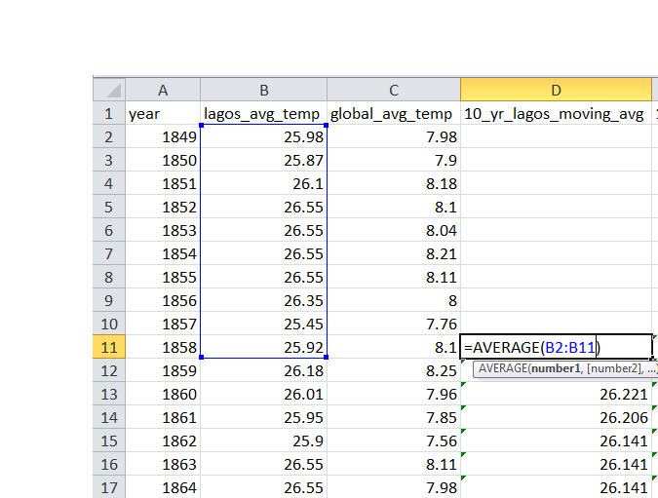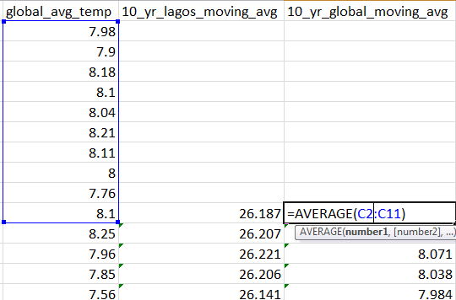

**STEP 3**:I plotted the 10 year moving average graph of Lagos average temperature and global average temperature as shown below:

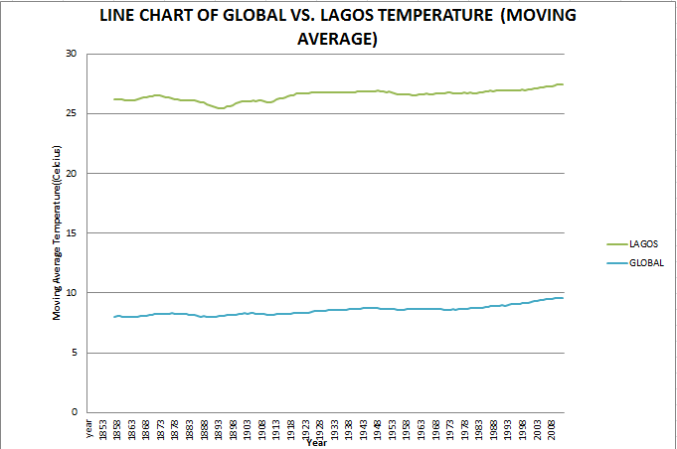

**OBSERVATIONS:**

* Lagos average temperature is hotter than global average temperature
* There is steady increase in temperature for both Lagos and global temperature which could be an effect of the global warming
* Lagos experienced its lowest average temperature in 1890 at 24.86˚C
* Between 1886 and 1898, Lagos recorded its lowest average temperatures thus far
* The average temperature for Lagos is 25.98˚C while that of global is 8.55˚C
* The average difference between Lagos temperature and Global temperature is 17.43˚C
* Lagos temperature increased from 25.98˚C in 1849 to 27.36 in 2013 while the Global temperature increased from 7.98˚C in 1849 to 9.61˚C in 2013